**Data Structure Lab**

Name: Megha Patel

Rollno: 20124107

P1) **write a C program to read and print student detail using structure pointer**

#include <stdio.h>

struct student

{

char name[30];

int roll;

};

int main()

{

struct student std;

struct student *ptr;

ptr= &std;

printf("Enter Name of student :: ");

scanf("%s",ptr->name);

printf("Enter Roll No of student :: ");

scanf("%d",&ptr->roll);

printf("\ndetails of student are :: \n");

printf("\nName : %s \nRollNo: %d \n\n",ptr->name,ptr->roll);

return 0;

}

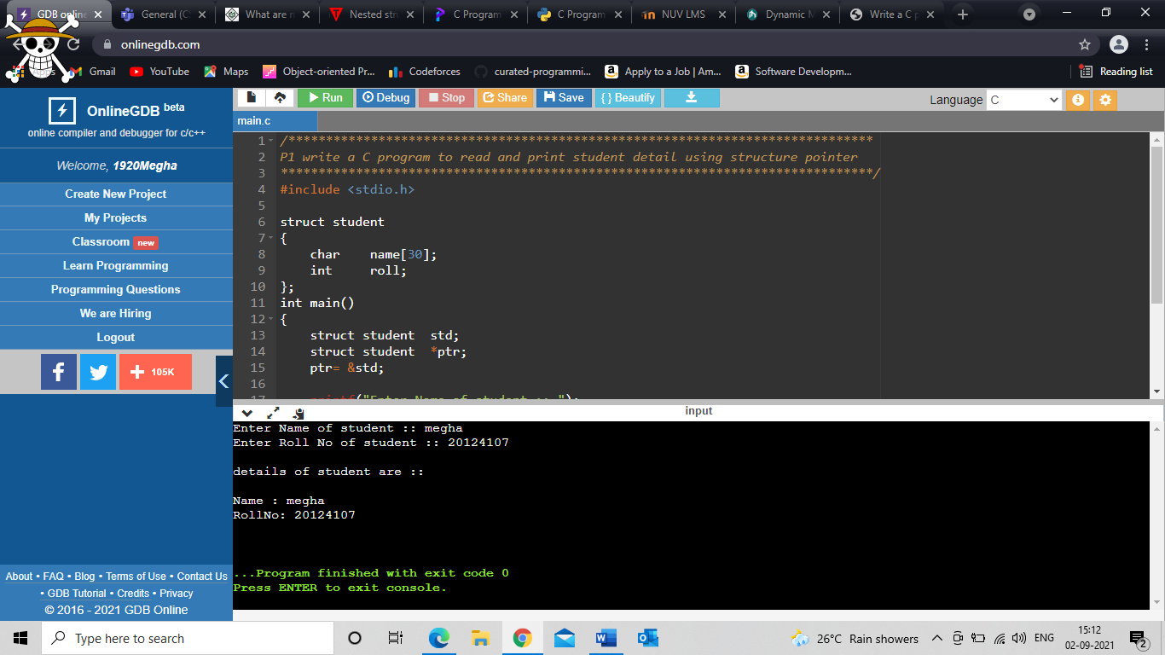

**2. Write a C program to add two complex numbers by passing structure to a function.**

#include <stdio.h>

typedef struct complex{

float rl;

float img;

float sum;

}complex;

complex add(complex n1, complex n2) {

complex temp;

temp.rl = n1.rl + n2.rl;

temp.img = n1.img + n2.img;

return (temp);

}

int main(){

complex n1,n2,ans;

printf("For 1st complex number \nenter real part");

scanf("%f",&n1.rl);

printf("enter imaginary part");

scanf("%f",&n1.img);

printf("\nFor 2st complex number \nenter real part");

scanf("%f",&n2.rl);

printf("enter imaginary part");

scanf("%f",&n2.img);

ans=add(n1,n2);

printf("\nresult = %.1f + %.1fi", ans.rl, ans.img);

return 0;

}

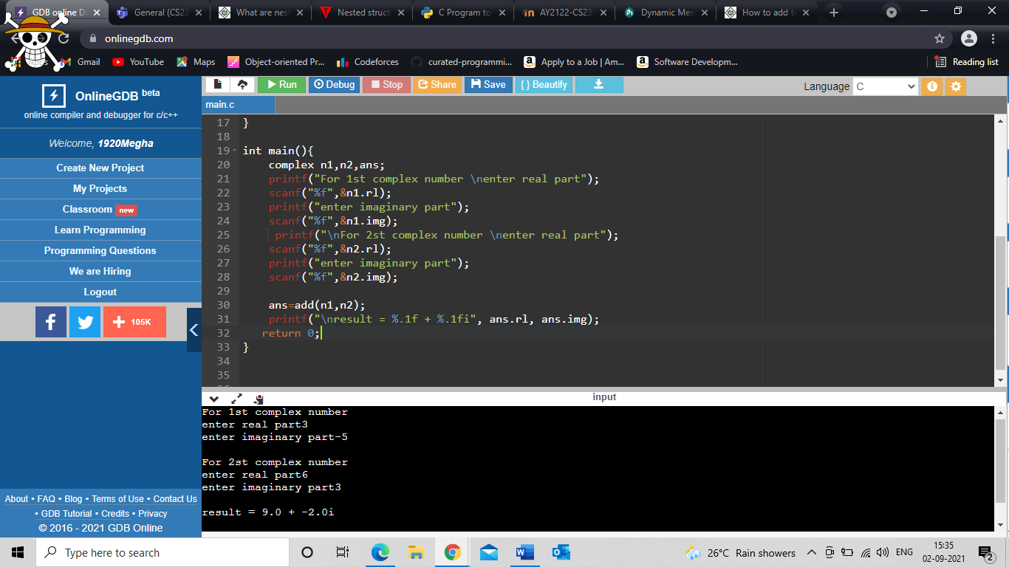

**3)Write a C program to calculate difference between two-time periods (Using call by reference).**

#include <stdio.h>

struct TIME

{

int seconds;

int minutes;

int hours;

};

void difference(struct TIME n1, struct TIME n2, struct TIME *diff)

{

if(n2.seconds >n1.seconds){

--n1.minutes;

n1.seconds += 60;

}

diff->seconds = n1.seconds - n2.seconds;

if(n2.minutes > n1.minutes){

--n1.hours;

n1.minutes += 60;

}

diff->minutes = n1.minutes - n2.minutes;

diff->hours = n1.hours - n2.hours;

}

int main()

{

struct TIME t1, t2, diff;

printf("Enter hours, minutes and seconds respectively for 1st value: \n");

scanf("%d %d %d", &t1.hours, &t1.minutes, &t1.seconds);

printf("\nEnter hours, minutes and seconds respectively for 2nd value::\n ");

scanf("%d %d %d", &t2.hours, &t2.minutes, &t2.seconds);

difference(t1, t2, &diff);

printf("\nTIME DIFFERENCE: %dh:%dm:%ds - ", t1.hours, t1.minutes,t1.seconds);

printf("%dh:%dm:%ds ", t2.hours, t2.minutes, t2.seconds);

printf("= %dhours:%dminutes:%dseconds\n", diff.hours, diff.minutes, diff.seconds);

return 0;

}

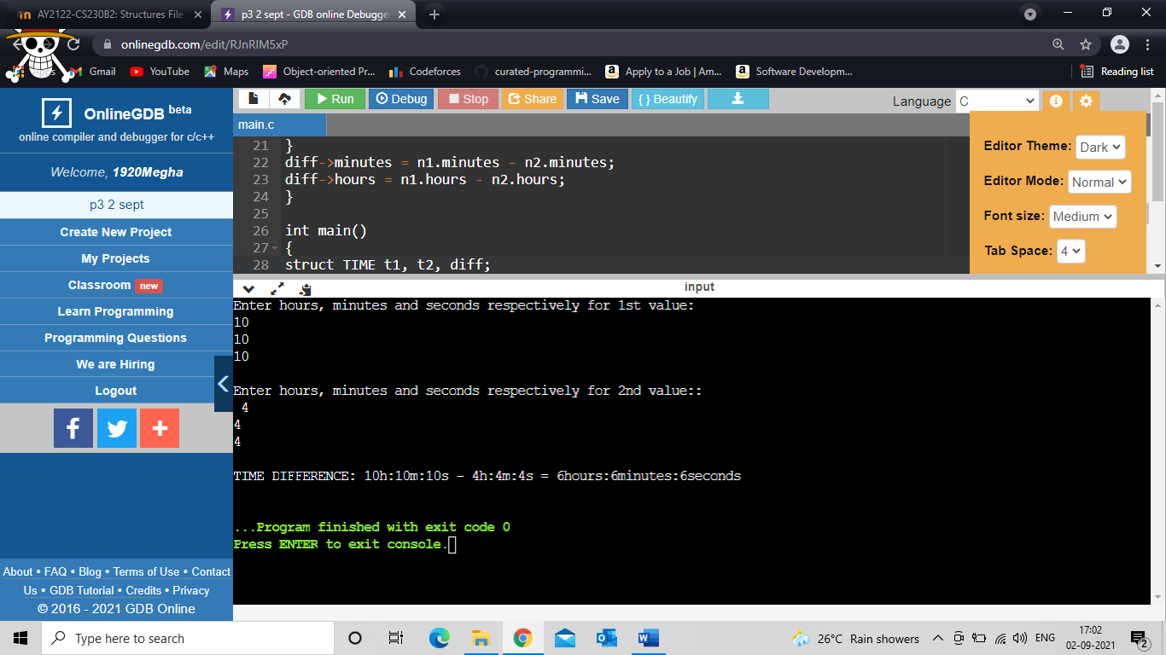

**4)rite a C program to read and print the N book details using structure and Dynamic memory allocation**.

#include <stdio.h>

#include <stdlib.h>

struct book {

int price;

char name[30];

};

int main() {

struct book *ptr;

int noOfRecords;

printf("Enter the number of book detail record: ");

scanf("%d", &noOfRecords);

// Memory allocation for noOfRecords structures

ptr = (struct book *)malloc(noOfRecords * sizeof(struct book));

for (int i = 0; i < noOfRecords; ++i) {

printf("enter name and price of book:\n");

scanf("%s", (ptr + i)->name);

scanf("%d",&(ptr + i)->price);

}

printf("Displaying Information:\n");

for (int i = 0; i < noOfRecords; ++i) {

printf("name: %s \t - price %d Rs\n", (ptr + i)->name, (ptr + i)->price);

}

free(ptr);

return 0;

}

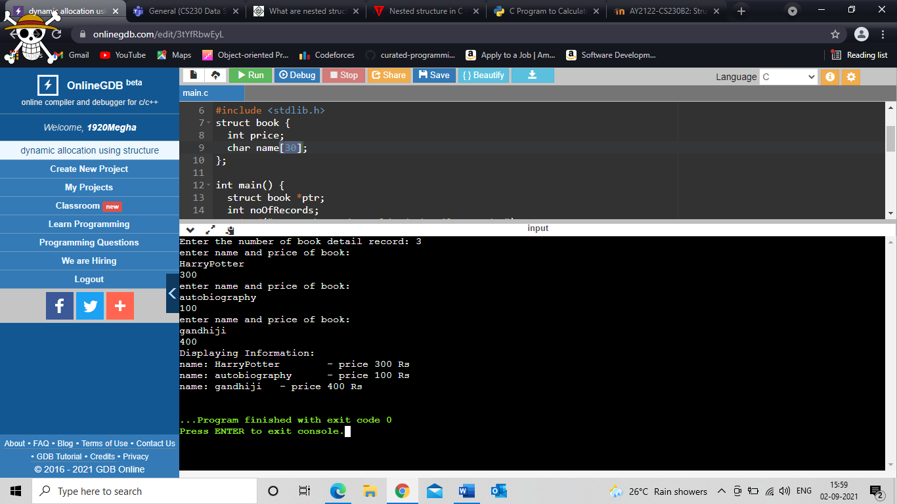

**5. Nested Structure in C: Demonstrate the example of separate and embedded structure.**

#include<stdio.h>

struct bddate

{

char month[20];

int day;

int year;

struct adress{ //embeded

char house[500];

char Street[500];

char City[100];

}p;

}a;

struct person //separate

{

char name[20];

struct bddate bd;

};

void main ()

{

struct person pr;

printf("Enter name and birthday in form of day/month/year\n");

scanf("%s %d %s %d",&pr.name,&pr.bd.day,&pr.bd.month,&pr.bd.year);

printf("\nenter the adress of this person in form of houseNO street city\n");

scanf("%s %s %s",&a.p.house,&a.p.Street,&a.p.City);

printf("\n\nPrinting name and birthday of person\n");

printf("name:%s birthday = %d / %s / %d\n",pr.name,pr.bd.day,pr.bd.month,pr.bd.year);

printf("his/her adress= %s %s %s",a.p.house,a.p.Street,a.p.City);

}

